21BDS0340

Abhinav Dinesh Srivatsa

Information Security and Audit Lab

Task – I

**Question 1**

Aim: Create a LAN using a hub with 3 nodes.

Tools and Concepts Required:

* Cisco Packet Tracer
* Hub
* Personal Computers
* Wiring
* Sniffer

Procedure:

* Create a LAN with a hub
* Understand the packet flow with the ping command
* Introduce a sniffer into the network
* Understand the working of a sniffer

Output:

LAN with hub:

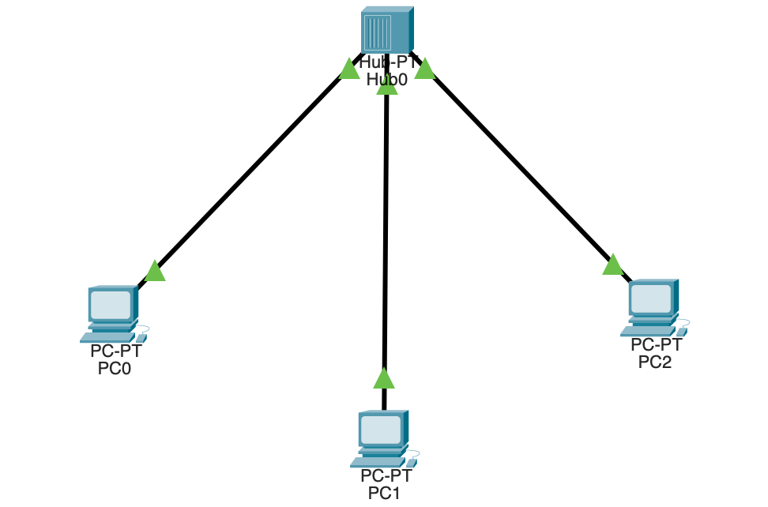

Understand the packet flow with the ping command:

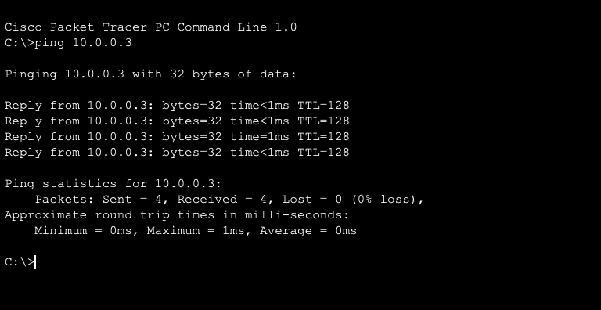

Introduce a sniffer into the network:

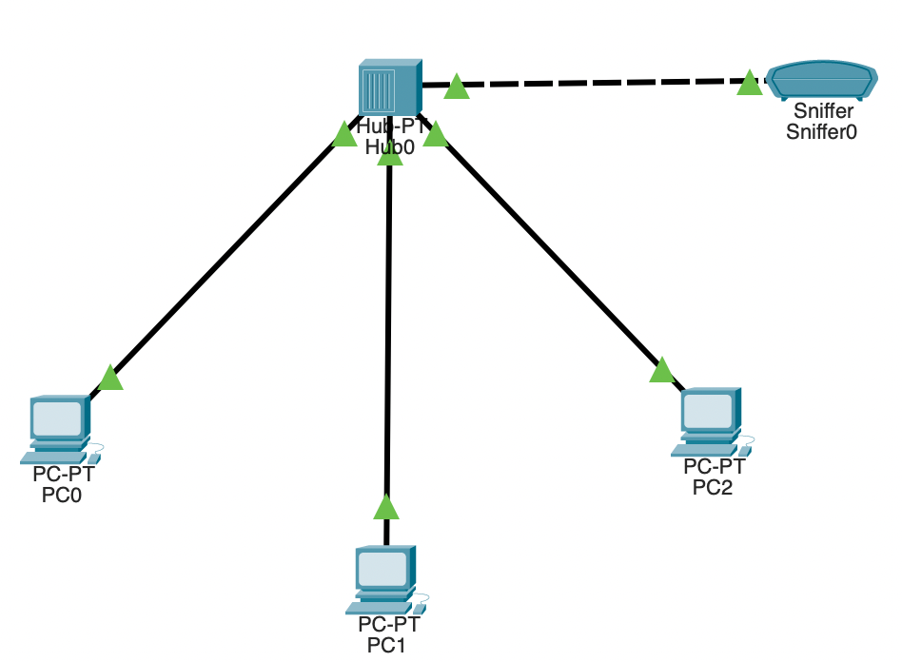

Understand the working of a sniffer:

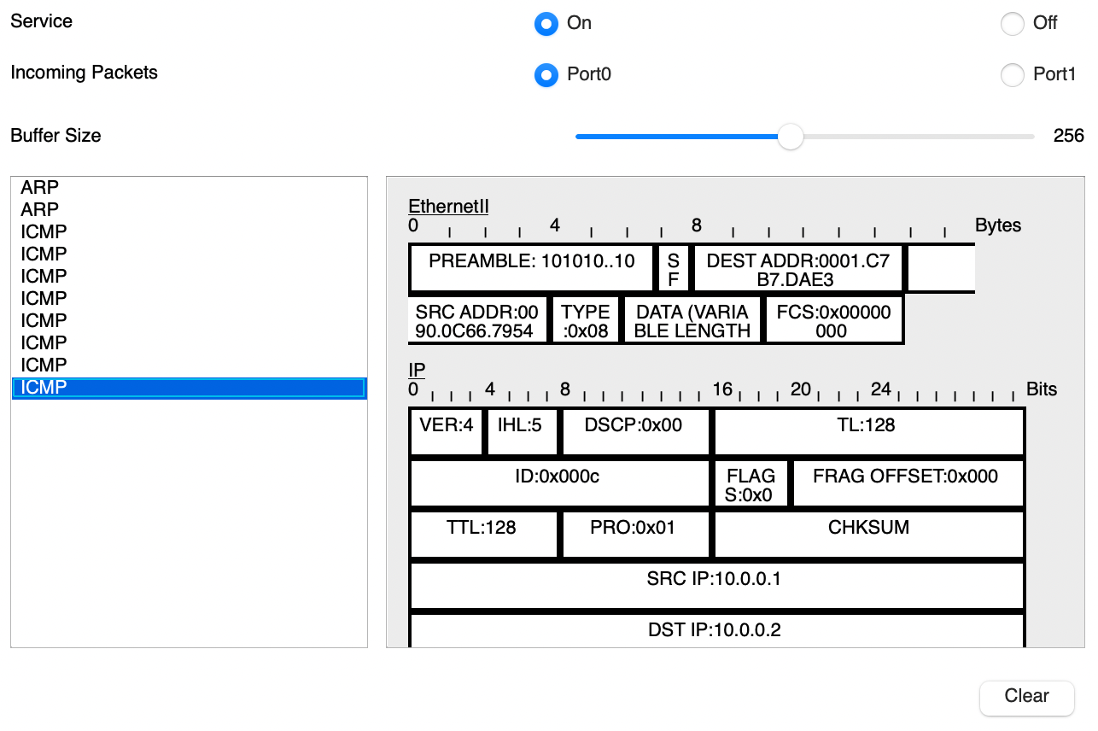

Security Analysis:

|  |  |  |
| --- | --- | --- |
| Vulnerabilities | Threats | Attack |
| Outdated software | Physical access with insider access | Malware infection to hardware by insider access |
| Weak passwords | Unauthorised access by gaining a password | Denial of service by blocking hub access |
| Lack of encryption | Data theft by insider attacks | Phishing by insider attack |
| Direct offline hub access |  |  |

Prevention:

* Keeping the nodes and hub in a sperate room for nobody to access directly.
* Encrypt and mandate strong password usage

Result:

This network is extremely secure, but all the nodes can only connect to each other and none of them to the internet. This type of connection is very good for local file storages and broadcasting.

**Question 2**

Aim: Create a LAN using a switch with 3 nodes.

Tools and Concepts Required:

* Cisco Packet Tracer
* Switch
* Personal Computers
* Wiring
* Sniffer

Procedure:

* Create a LAN with a switch
* Understand the packet flow with the ping command
* Introduce a sniffer into the network
* Understand the working of a sniffer

Output:

LAN with switch:

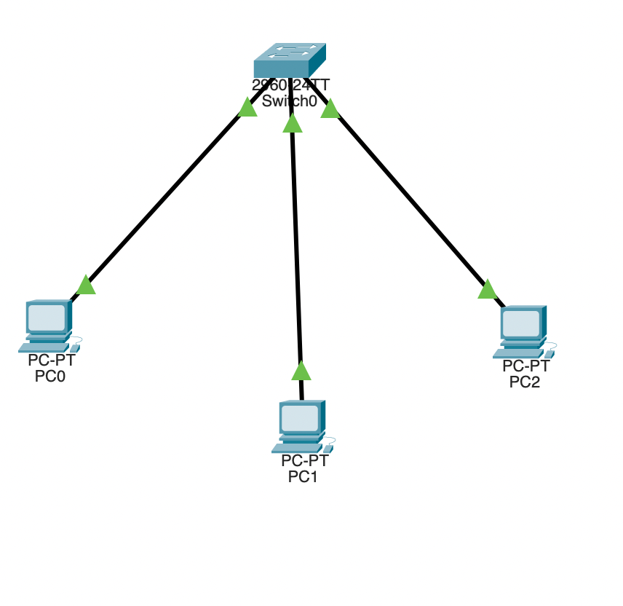

Understand the packet flow with the ping command:

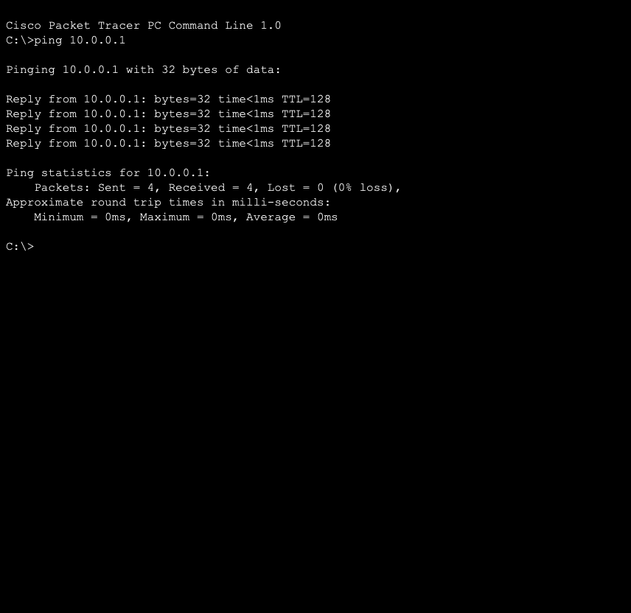

Introduce a sniffer into the network:

Understand the working of a sniffer:

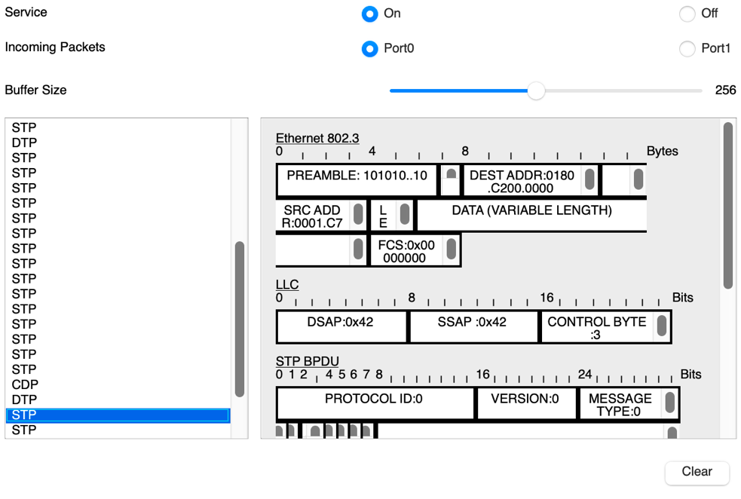

Security Analysis:

The setup will have the exact same security analysis as with the first question (hub instead of switch)

|  |  |  |
| --- | --- | --- |
| Vulnerabilities | Threats | Attack |
| Outdated software | Physical access with insider access | Malware infection to hardware by insider access |
| Weak passwords | Unauthorised access by gaining a password | Denial of service by blocking hub access |
| Lack of encryption | Data theft by insider attacks | Phishing by insider attack |
| Direct offline hub access |  |  |

Prevention:

* Keeping the nodes and hub in a sperate room for nobody to access directly.
* Encrypt and mandate strong password usage

Result:

This network is extremely secure, but all the nodes can only connect to each other and none of them to the internet. This type of connection is very good for local file storages or for fast computer communication.